|  |  |  |  |  |
| --- | --- | --- | --- | --- |
| Student Name: | Hanlin Cai |  | Student Name: | 蔡汉霖 |
| Maynooth ID: | 20122161 |  | Fuzhou University ID: | 832002117 |

## EE211 MATLAB Assign2:

Statement：

Alternatives：**A MATLAB/Simulink environment**

The data set given to me by the TA is shown below:

f_0 = 10; A1 = 6; A2 = 6; A3 = 6; k1 = 6; k2 = 8; h3 = 0.1;

All the Code & Picture were designed and created by myself,

and I never share them with others.

Procedure 1

Picture for procedure1:

If we can assume the system is linear, we can model it by a linearized model. Just As shown in Fig-1:

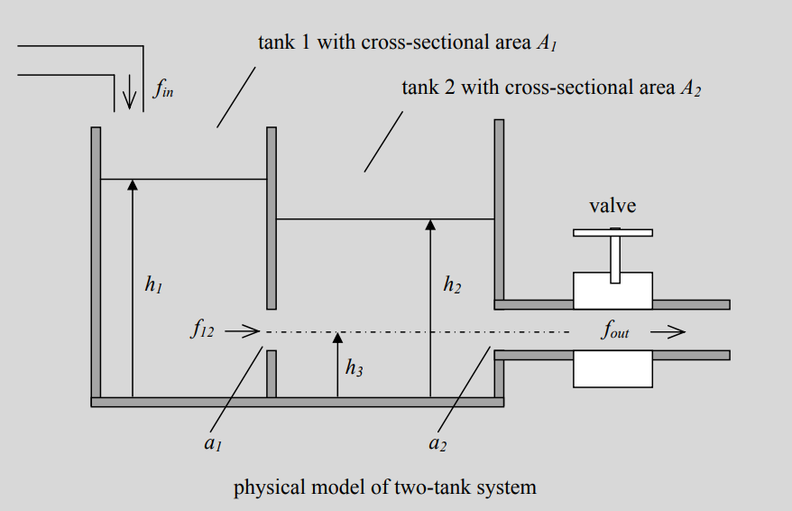

Pic-1 physical model of 2-tank system

Therefore, we can use the formula below:

Then, we can get the flow balance equations for each tank:

Since and ,we can get：

Finally, we can obtain the final dynamic model of the 2 tank system as follows:

Ultimately we can plug the data into the formula:

So, this is the linearized model.

Procedure 2

Picture 2:

The simulation models are provided.

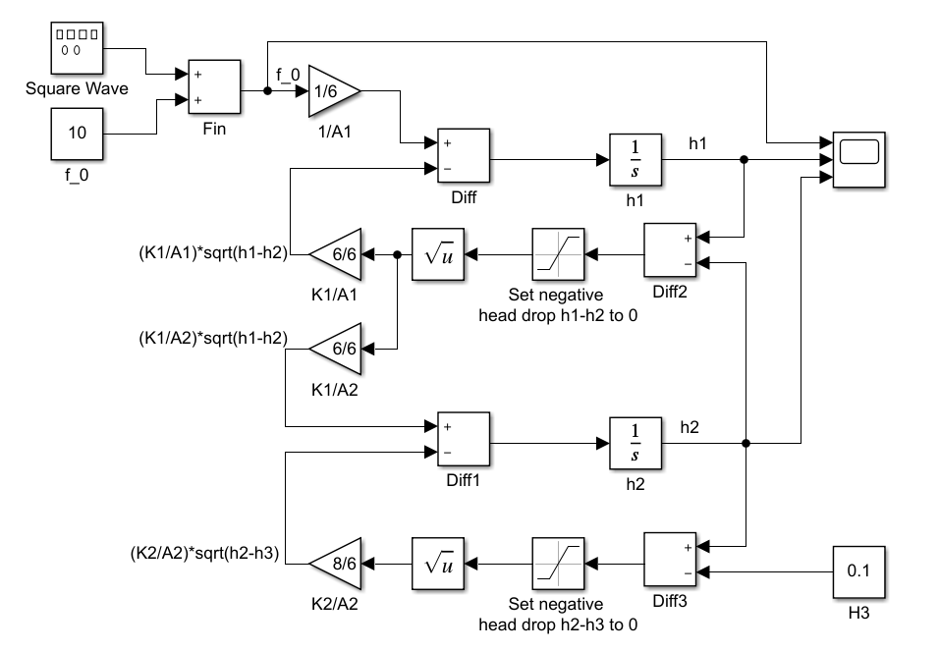

Pic-2 Simulink Modelling-1

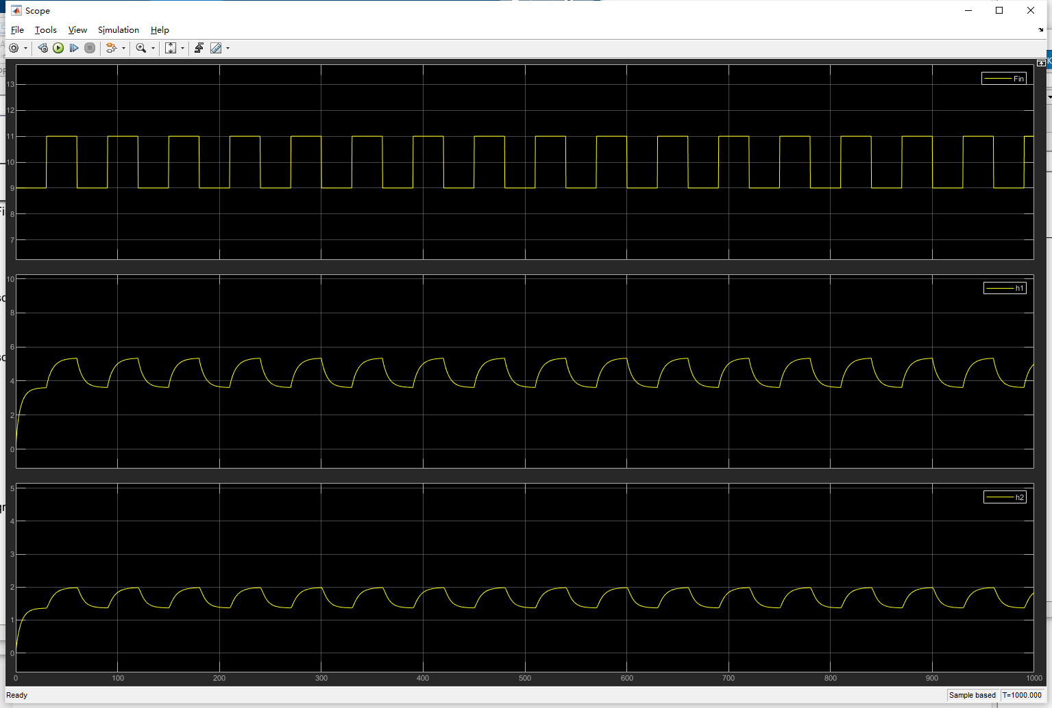

Pic-3 for dataset-1 (0.1*)

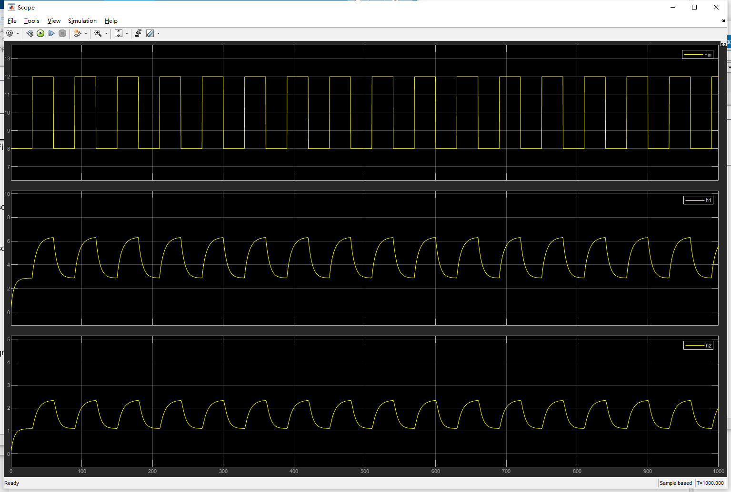

Pic-4 for dataset-2 (0.2*)

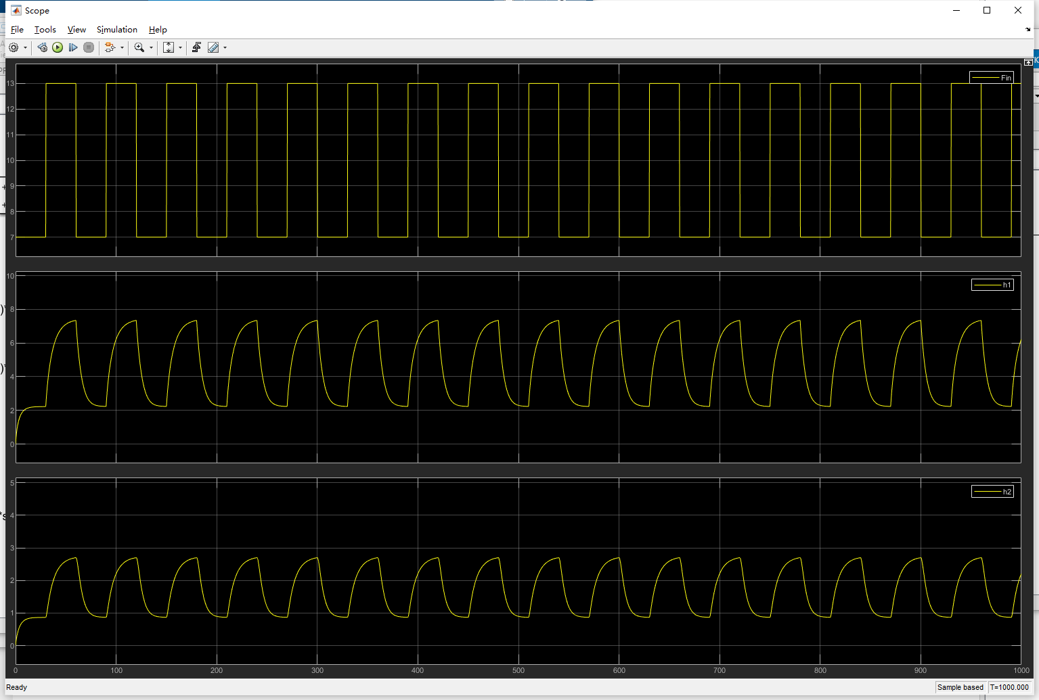

Pic-5 for dataset-3 (0.3*)

CODE :

%% Matlab Assign2_1 by Hanlin Cai

% Plugging the data into the simulink model

f_0 = 10;

A1 = 6;

A2 = 6;

A3 = 6;

k1 = 6;

k2 = 8;

h3 = 0.1;

per1 = 60;

fre = 1/per1;

% amp1 = 0.1*f_0;

% amp2 = 0.1*f_0;

% amp3 = 0.1*f_0;

Procedure 3

Picture 3:

The linearized model equation:

So, we can get its state-space equation:

; ;

Therefore, we obtain the equation below (where u = = 10):

State-space simulation shows the jitter of the approximate turbulence model near the equilibrium point:

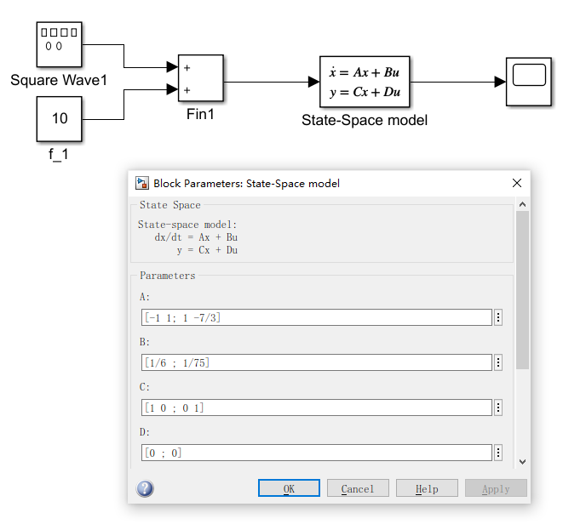

Pic-6 Stace-Space modelling

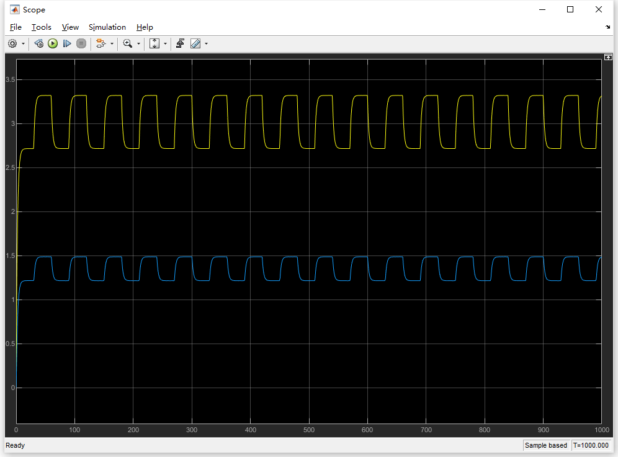

Pic-7 for dataset-1 (0.1*Fin)

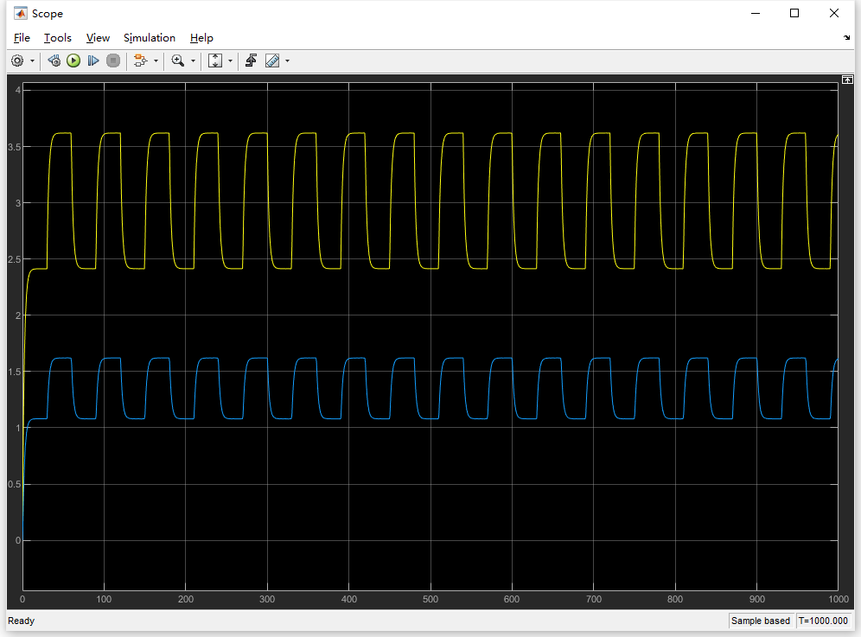

Pic-8 for dataset-2 (0.2*Fin)

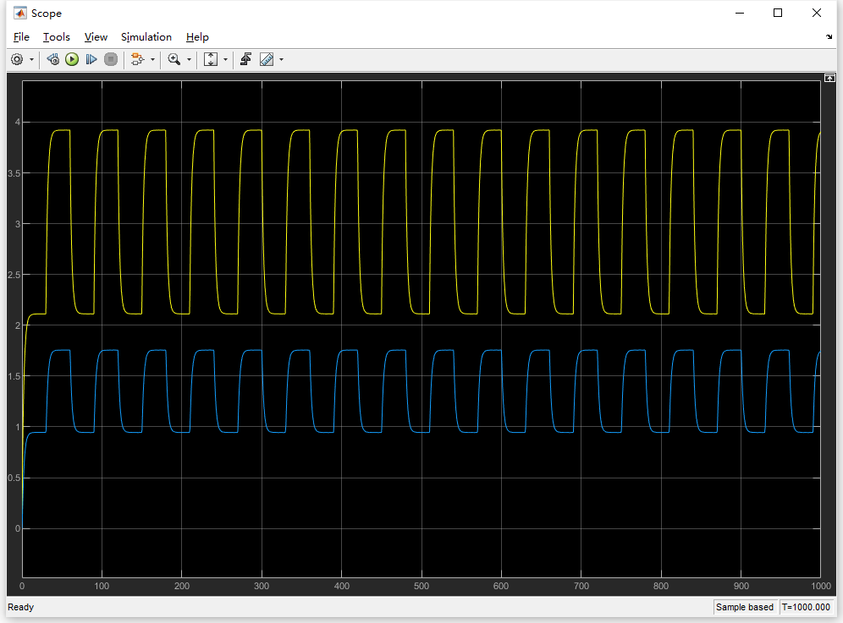

Pic-9 for dataset-3 (0.3*Fin)

Addition: the linear simulation models below are recreated by Hanlin Cai:

The linear model removed by the square root is a laminar flow model similar to the output of the turbulence model.

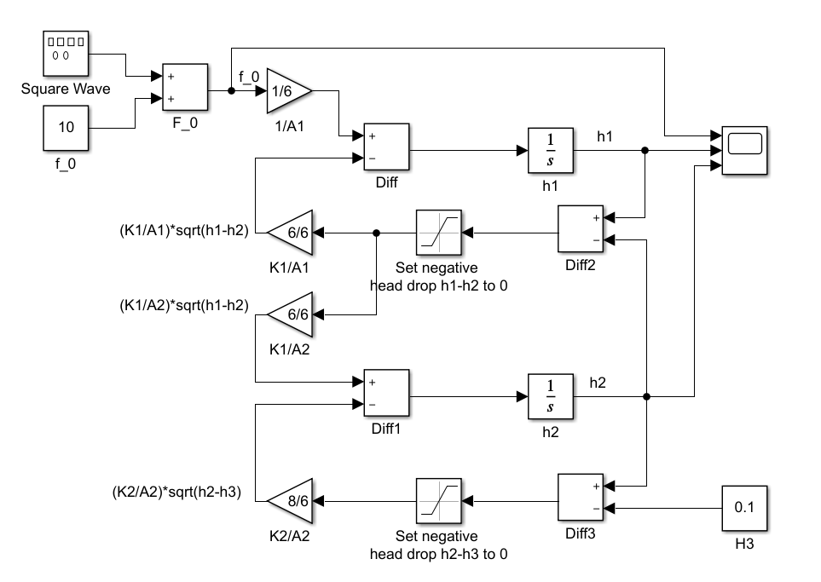

Pic-10 Simulink Modelling-2

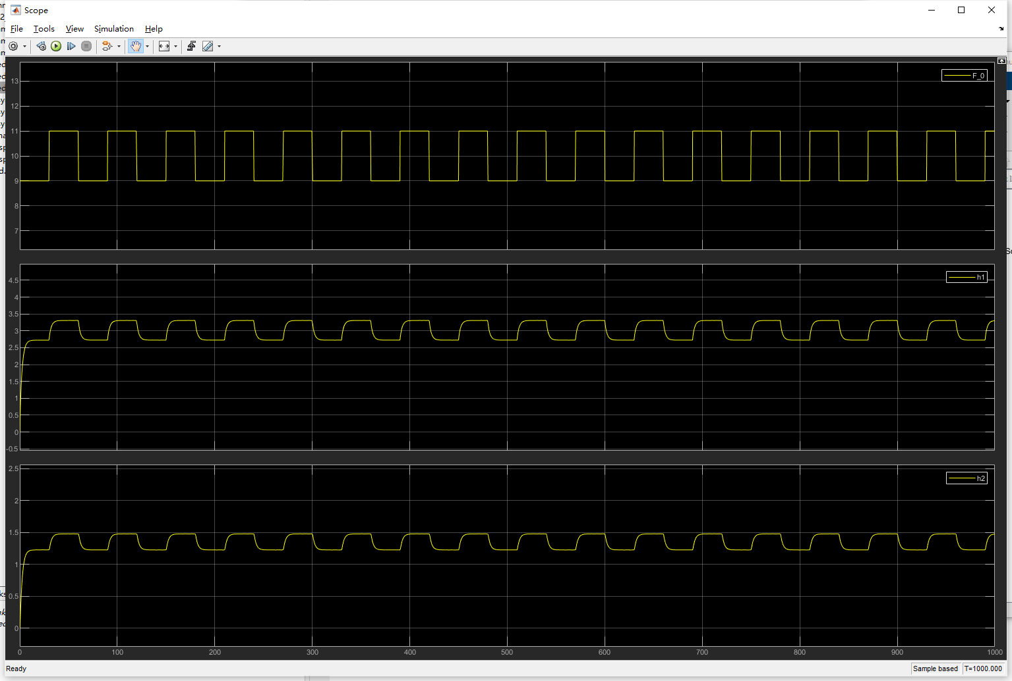

Pic-11 for dataset-4 (0.1*)

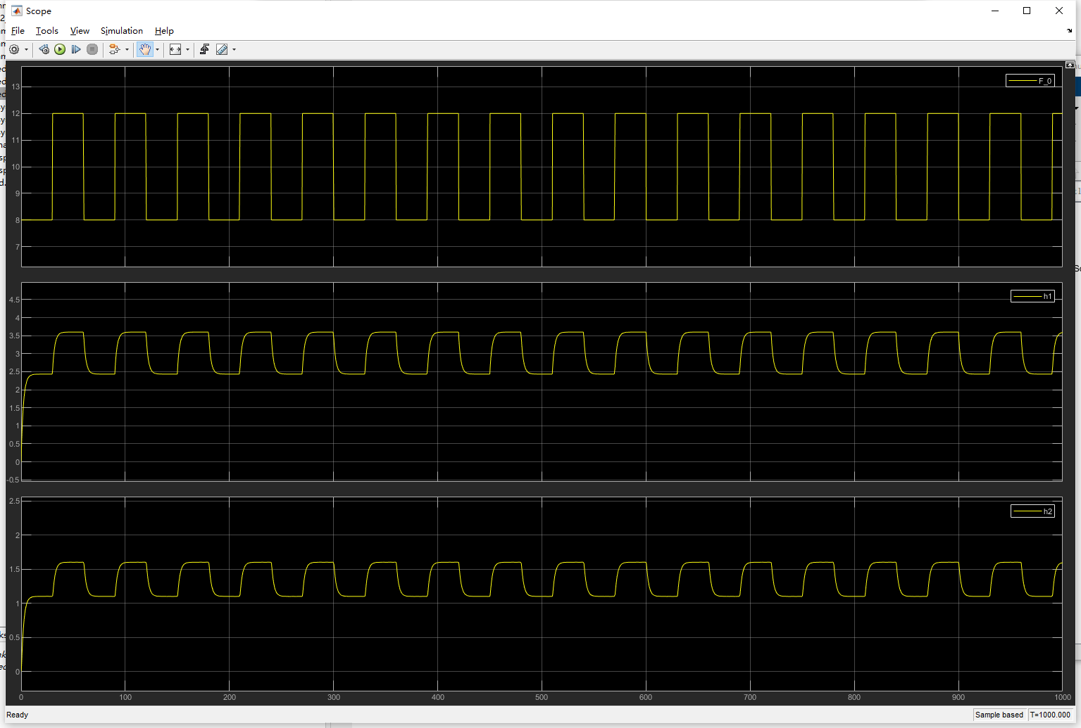

Pic-12 for dataset-5 (0.2*)

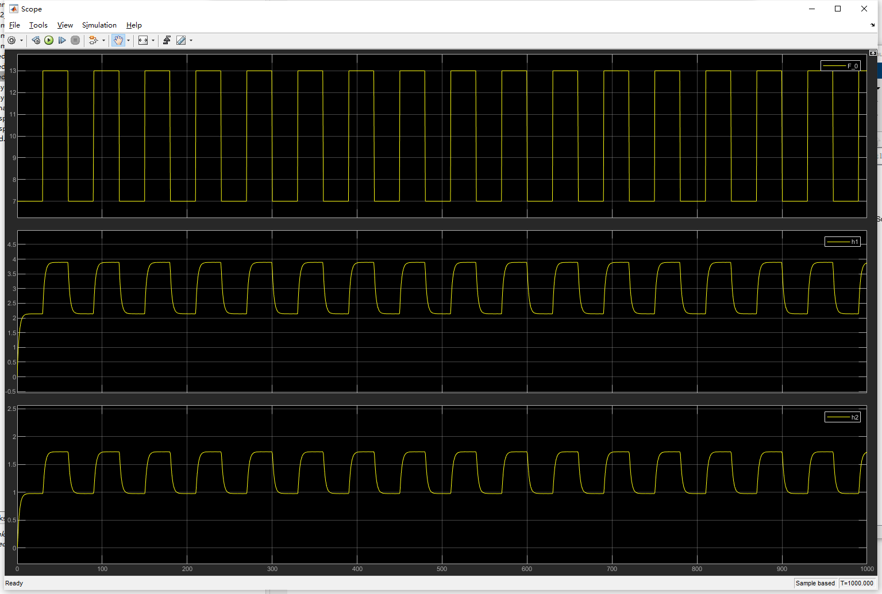

Pic-13 for dataset-6 (0.3*)

Procedure 4 Comment on the result

Through compare the responses obtained from procedure 2 and 3, I found that when the height is close to two extremes, the highest point and the lowest point, the linearization model cannot accurately fit the state of the coupled tanks system. Just as the Picture shown below:

Pic15-17

Procedure 5

We already get the linearized model equation of the system:

Then at equilibrium . Hence:

After simplifying , we get:

Squaring both sides, we obtain the laminar model:

In the same way, we can obtain the turbulent model :

So we can easily get when , the difference between laminar model and turbulent model is the smallest.

Therefore, we can plug the data into the MATLAB model for validation:

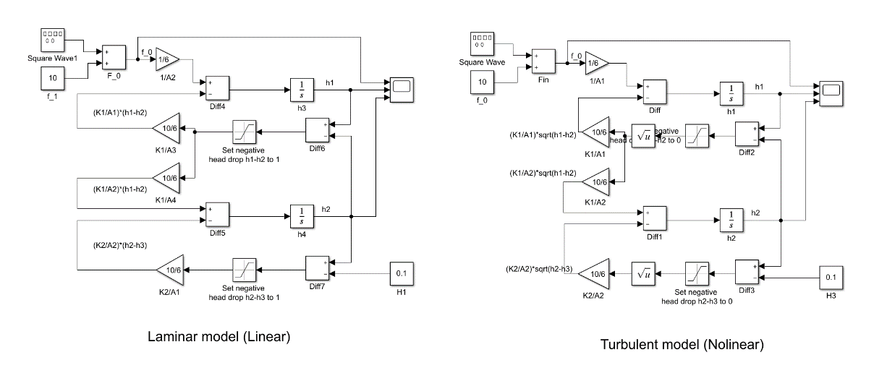

Pic-18

Now, comparing this model (using the linear system simulation) to that of the linearized (turbulent flow) model:

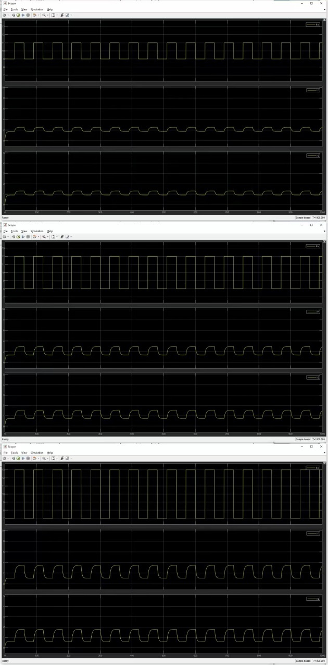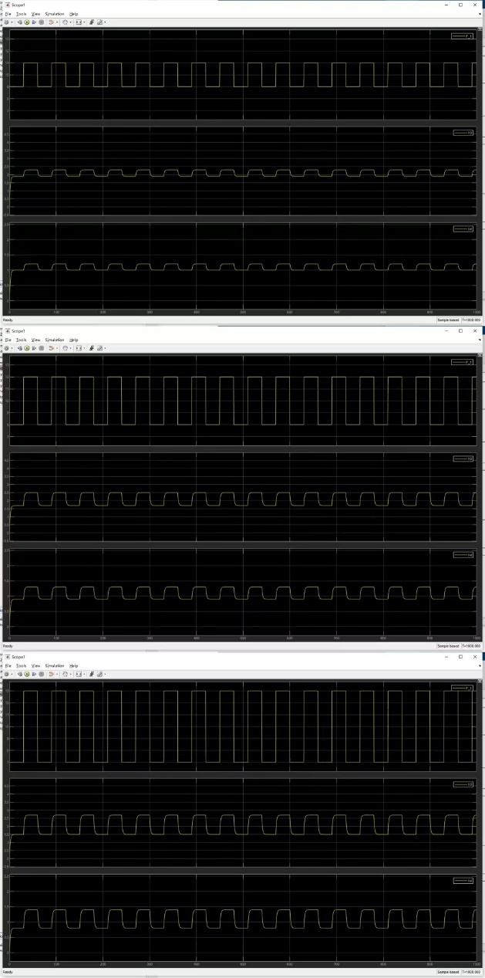

Pic 19-20

Comment : I consider that within the margin of error, the result between this model and the linearized model are quite accurate, and it’s a really successful simulation work!

In addition, we can also use the State-Space model to compare:

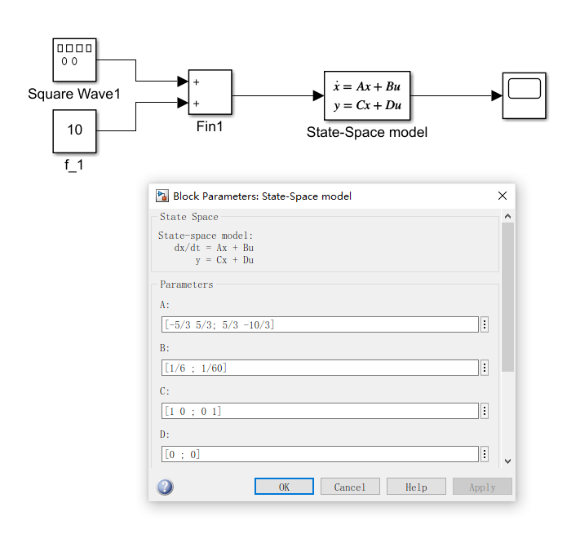

Pic 21

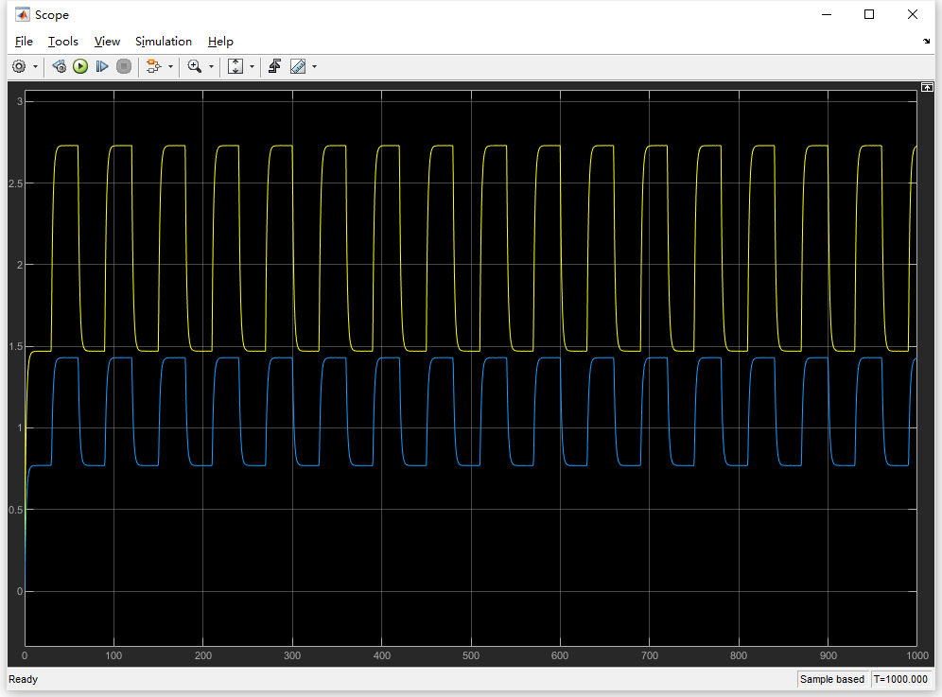

Pic 22

Extra Question

If we use a different equilibrium input flowrate:

In = 5:

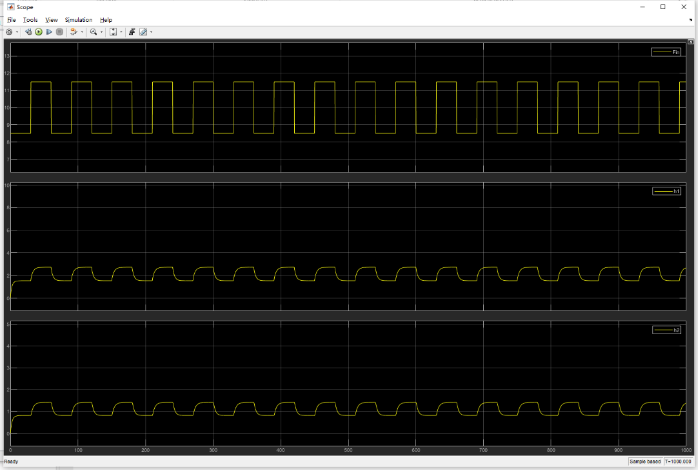

Pic 23

In = 10, just the same as before:

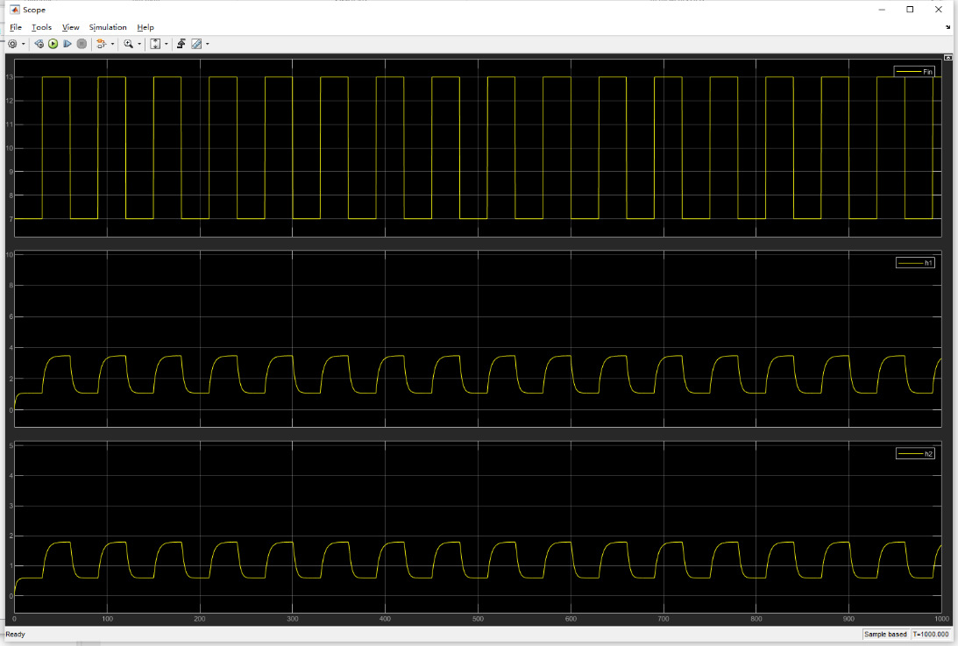

Pic 24

In = 20:

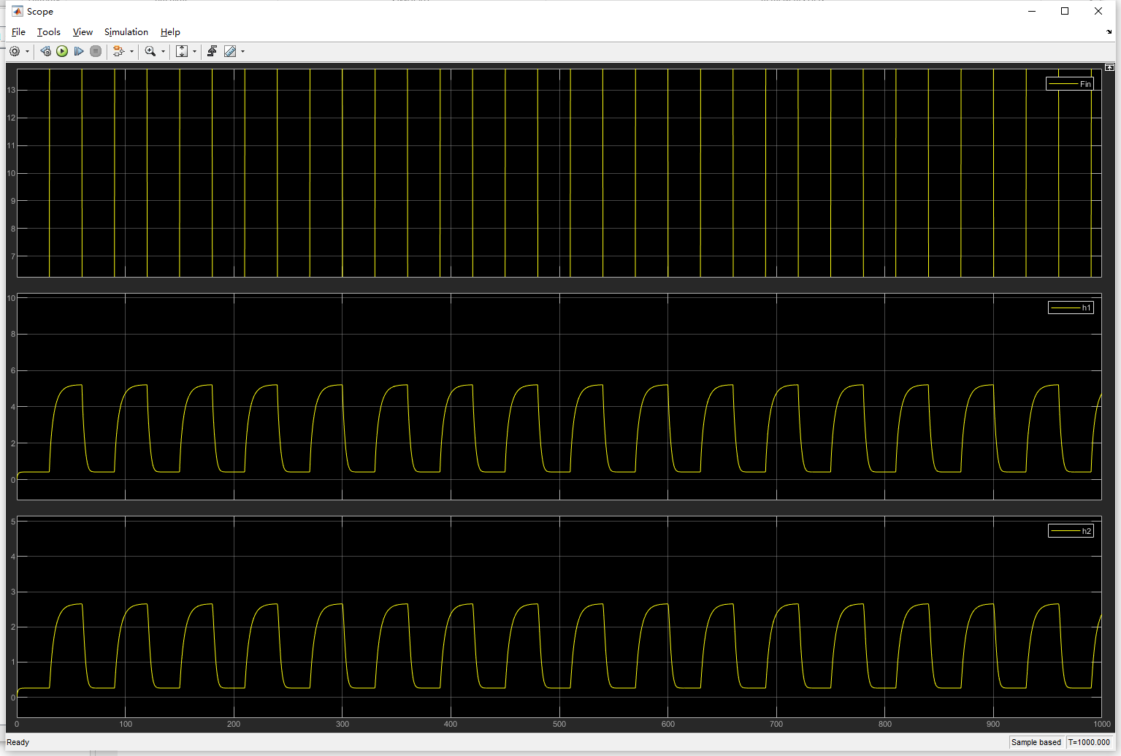

Pic 25

In = 30:

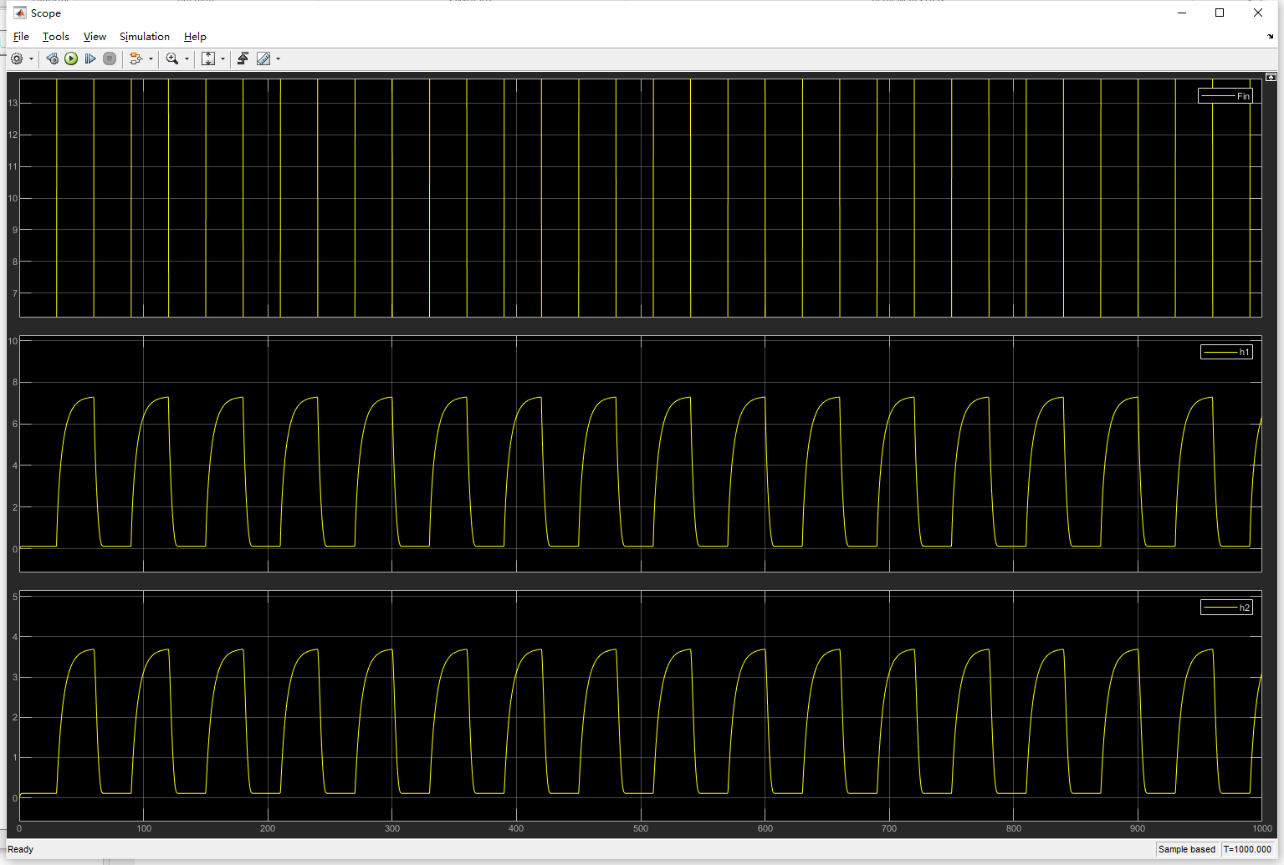

Pic 26

Comment: As pic23-26 shown, as the input flowrate get bigger and bigger, the data in the pole get bigger too, but the speed of reaching the pole is almost constant. This tell that the speed of response is almost independent of the input flowrate.

A summary of what I gained in this Assignment

Through this assignment, I get familiar with how to simulate a complex model (Such as coupled tanks system) by MATLAB/Simulink. Although this assignment was very difficult for me at the beginning, I finally finished it well through independent study and continuous trying.

Acknowledgement

I would like to thank my professor, Zhicong Chen, and my TA, **Xunfeng Lin**, I’m really appreciate for your grateful patience and wisdom!